1.4 Define a base class person with attributes name and age

Create a subclass Employee the inherits from person and adds attributes like employeeID and salary

Use the super keyword to initialize the person attributes in the employee constructor.

Input;

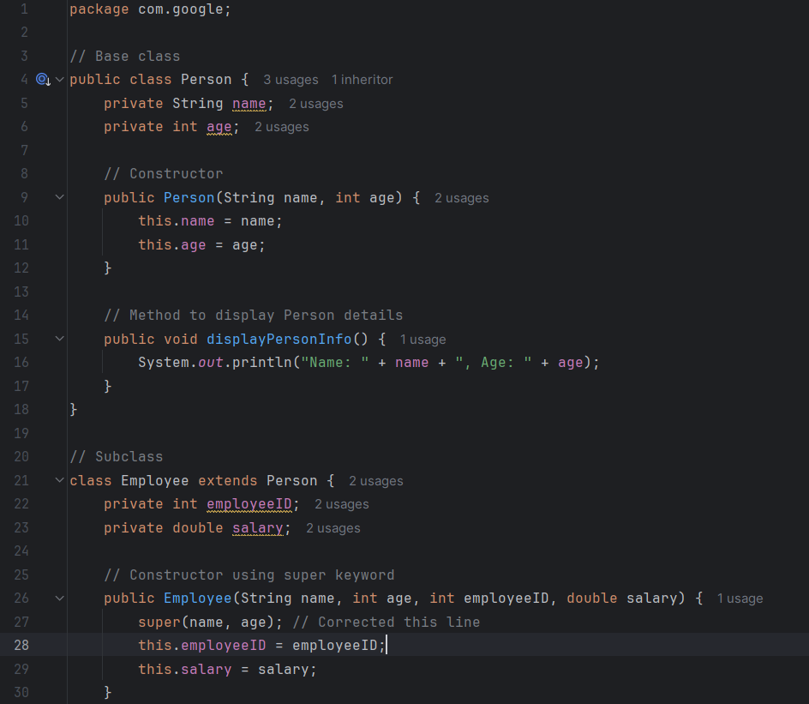

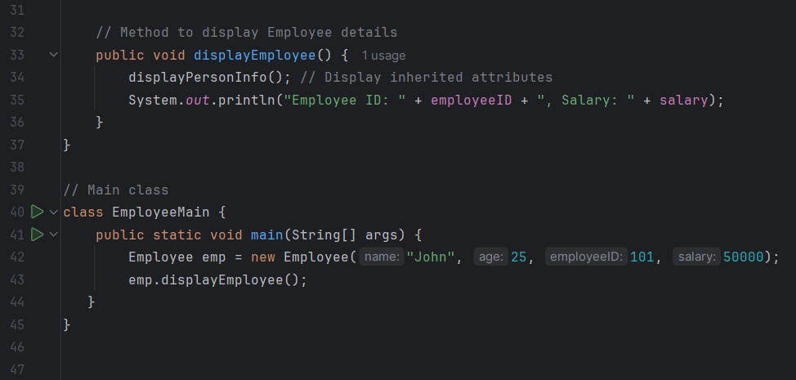

Output;

